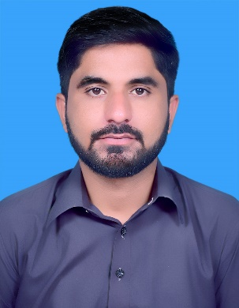

***Bilal Abbas***

*Software Engineer*

***Email:*** [***bilalabbas437@gmail.com***](mailto:bilalabbas437@gmail.com)

***Skype:*** *bilal.abbas437*

***Contact #:*** +92 301 5853980

***Objective****:*

*A Results-oriented, high-energy, possesses excellent management and communication skills, can function independently on multiple projects. Seeking long term employment in a growth oriented organization where I can grow professionally and enhance my skills and knowledge by being an integral part of the team that contributes towards the growth of the organization.*

***Professional Summary****:*

*I intend to enhance my skills and strengths under your true the professional, mature and specialized environment of Project Development and Management. I have completed my graduation from the University of the Wah. Also, I have worked in an organization the last year as Linux Administrator and work with DEVOPS team. I take ownership of the projects I create and am involved in. I am especially passionate about Open Source and this is something that moves me to achieve excellence, share and contribute to all areas of the company where it will be relevant. I believe that the knowledge and skills built up during my past make me the perfect one to serve your organization.*

*Now I want to extend my skills and knowledge under the professional environment for the growth of my professional career.*

***Skills:***

*HTML/CSS, Linux Administrator, Web Designing, Android Designer, Packet Tracer, Multiple APIs, MS OFFICE, Internet Surfing and browsing related information, Research Ability.*

***Work Experience****:*

***Position: Linux Administrator (Ubuntu) Internship***

***Brokergenius***

**Responsibilities:**

* System Configuration, Management and Automation(Ubuntu)
* Certification preparation form Linux Academy.
* Python.
* Communication with all the stake holders.

***Position: Devops Engineer***

***Brokergenius***

**Responsibilities:**

* *Worked as Development and Operation Team Member. (DevOps)*
* Black box testing and Performing Penetration testing.

***Projects Detail:***

***Project:* A Web Site: Talking Hands to Reduce Communication Gap *Final Year Project***

**with Hearing and Speech Impaired Persons.**

***Company: University of Wah,***

*Description:*

* *Developing Web Based Application for Impaired people for communication.*
* *Usability will be testified at “Nasheman”, institute of special children.*

*For more information visit*

* [*https://drive.google.com/open?id=16Wg90Ct7orIVrtgG_e_gqBFPbrMCzjQ8*](https://drive.google.com/open?id=16Wg90Ct7orIVrtgG_e_gqBFPbrMCzjQ8)

***Qualification:***

***BS (Hons) Computer Science*** ***2014-2018***

*University of Wah, Quaid Avenue*

*Wah Cantt.*

***Personal Information:***

*Date of Birth: 24th Dec, 1995*

*Nationality: Pakistani*

*Religion: Islam*

***References:***

*References are available on request.*